Andrew Stiles
CSD-340
Assignment 1-2
3/30/2025

GitHub Repository Link: adstiles85 (Andy Stiles)

Screenshot of Local Directory:
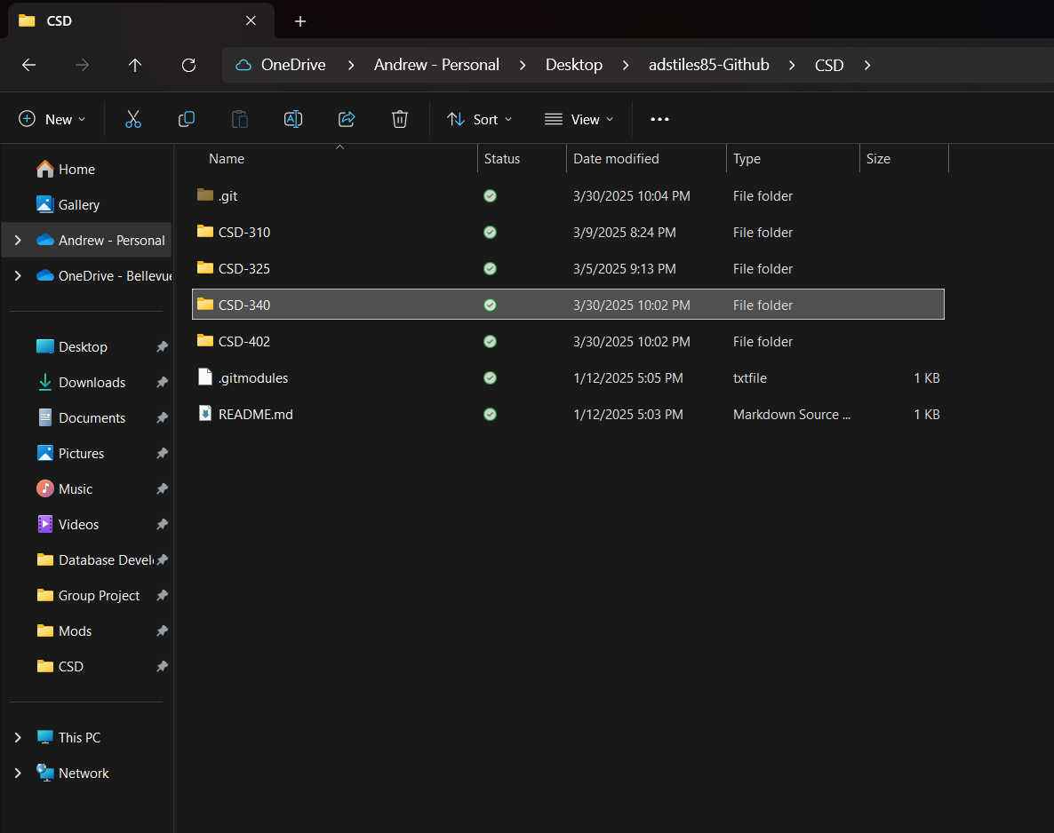

GitHub Repository Screenshot:
